

Diplomacy Desktop App - User Manual

Jason Nguyen, Ellen Burger, Sadiq Sarwar, Sovathana Heng, Sophanna Ek, Vishant Khunti, Chelsea Marfil, Jessica Hilario

Group E

CECS 475

Professor Anthony Giacalone

February 28, 2019

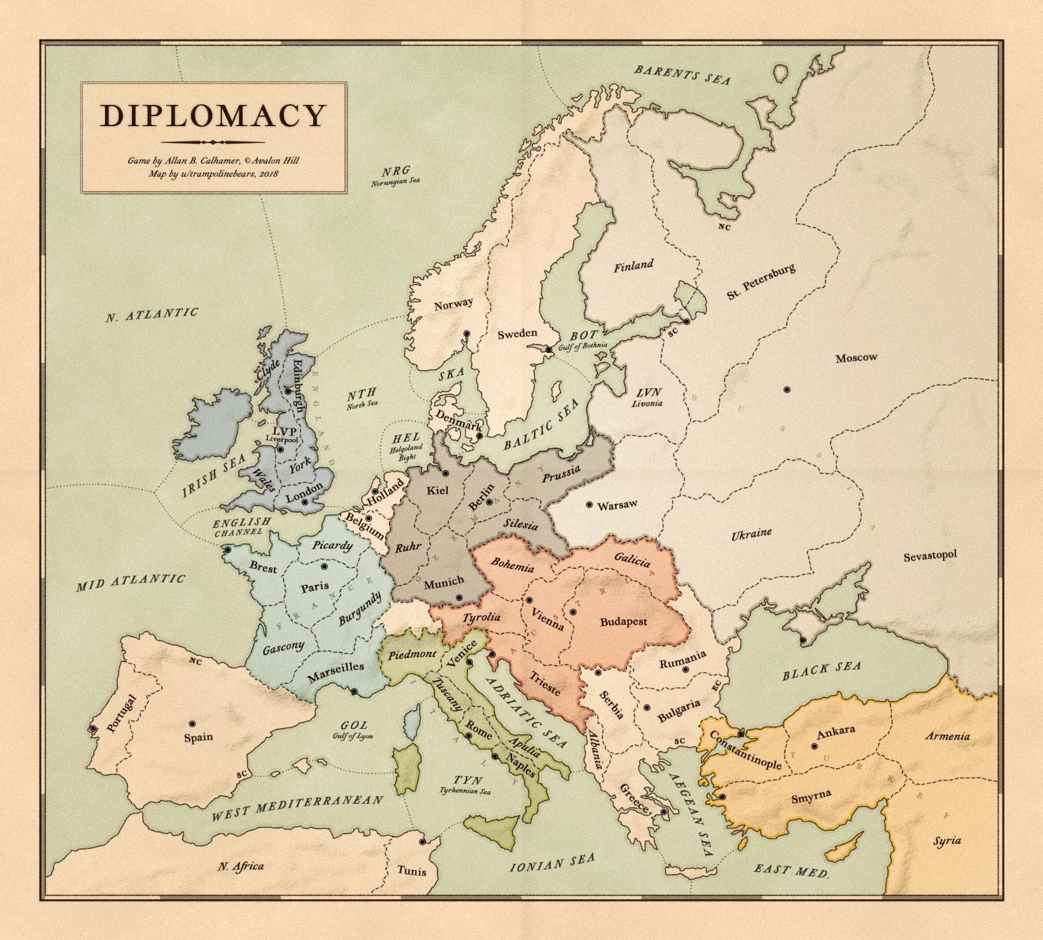

DIPLOMACY GAME MANUAL

Table of Contents

**1. INTRODUCTION**5

1.1 ABOUT DIPLOMACY 5

1.2 ABOUT THIS MANUAL 5

1.3 SYSTEM REQUIREMENTS 5

1.3.1 MINIMUM SYSTEM REQUIREMENTS 5

1.3.2 OTHER REQUIREMENTS 5

1.4 DOWNLOADING 5

1.5 THE TUTORIAL **Error! Bookmark not defined.**

**2. STARTING A GAME**6

2.1 THE MAIN MENU 6

2.1.1 CREATE GAME 6

2.1.1.1 THE CREATE GAME SCREEN 6

2.1.1.1.1 USERNAME (required field) 7

2.1.1.1.2 GAME NAME (required field) 7

2.1.1.1.3 GAME DESCRIPTION (optional field) 7

2.1.1.1.4 TYPE OF PLAYER (required field) **Error! Bookmark not defined.**

2.1.1.1.5 ADJUDICATION PERIOD (optional field) 7

2.1.2 JOIN GAME 7

2.1.2.1 GAME ID 7

2.1.2.2 USERNAME (required field) 7

2.1.2.3 TYPE OF PLAYER (required field) **Error! Bookmark not defined.**

2.1.3 HOW TO PLAY 7

2.1.4 EXIT **Error! Bookmark not defined.**

**3. THE INTERFACE**8

3.1 THE MAIN MAP 8

3.2 CLICK 9

3.3 CHAT ROOM 9

**4. THE GAME RULES**9

4.1 OVERVIEW 9

4.2 HOW TO PLAY 9

4.2.1 STARTING PHASE 9

4.2.2 ORDER PHASE 9

4.2.2.1 ORDER DATES 10

4.2.2.2 ORDER FORMAT 10

4.2.2.3 TYPES OF ORDERS 11

4.2.2.3.1 HOLD 11

4.2.2.3.2 MOVE 11

4.2.2.3.3 SUPPORT 11

4.2.2.3.4 CONVOY 11

4.2.2.5 RETREAT AND DISBAND UNITS 11

**5. FAQ**11

5.1 How many player(s) are needed? 11

5.2 What is the object of the game? 11

5.3 What are the playable countries? 12

5.4 What are the units and how do I move? 12

5.5 How do I get more troops? 12

5.6 What are the gameplay phases? 12

5.7 How do I attack? 12

5.8 What are the order types? 13

5.9 How do I win the game? 13

**Revision History**13

# 

# 

# 1. INTRODUCTION

Welcome to Diplomacy! In this game, you will take on the role of one of the seven greatest powers of Europe prior to World War I. These great powers include Austria, England, France, Germany, Italy, Russia, and Turkey.

Great diplomacy will bring you and your people success, and you could become the strongest military power in the world history.

## 1.1 ABOUT DIPLOMACY

Diplomacy is a strategic, turned based game that pits players against one another. Players must navigate the tumultuous game map in order to conquer territories and gain a strategic advantage. Diplomacy is ultimately a game of alliances, negotiations, and betrayal. In order to succeed, you must stand alone, but also know how to pick your enemies and allies. Only one player emerges victorious, after having conquered their former friends and enemies.

## 1.2 ABOUT THIS MANUAL

The manual will tell you everything you need to know about how to play our implementation of Diplomacy.

As always, we think that the best way to learn how to play is to understand all the rules which is accessible from the Main Menu.

## 1.3 SYSTEM REQUIREMENTS

### 1.3.1 MINIMUM SYSTEM REQUIREMENTS

Windows, MacOS, or Linux machine.

### 1.3.2 OTHER REQUIREMENTS

Initial installation requires Internet connection for downloading the application and git installed to clone the project’s repository.

## 1.4 DOWNLOADING

Our desktop app can be downloaded it online from our [GitHub page](https://github.com/JessicaHilario/475Diplomacy).

# 2. STARTING A GAME

After the game has been installed on your machine and you start the application, the welcome screen will be displayed.

## 2.1 THE MAIN MENU

The Main Menu appears after clicking play from the welcome screen. From the main menu, you can start the game by clicking ‘Create Game’ or ‘Join game’. You can also navigate to the “Rules and Objectives” page to learn all the rules and objectives of the game.

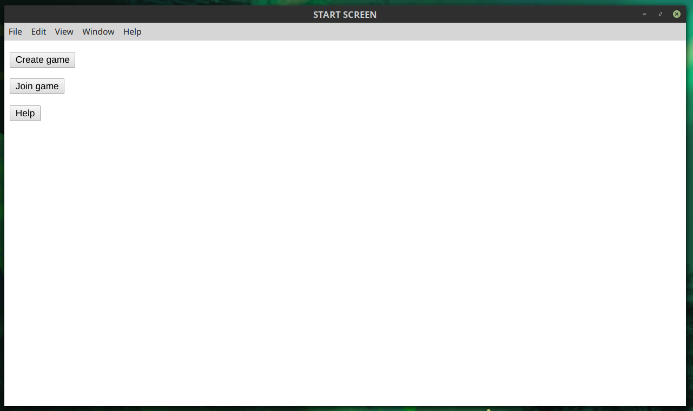

### 2.1.1 CREATE GAME

From the main menu, you can click the “Create Game” button. This will lead you to the ‘Create Game Screen’.

#### 2.1.1.1 THE CREATE GAME SCREEN

This screen will display a form where the game creator fills out and selects different fields which are detailed in the following subsections. When the game creator clicks the “Submit” button on the form, a Game ID is generated which can be shared with other users to either spectate or join the game.

##### 2.1.1.1.1 USERNAME (required field)

Game creator enters their username in the textbox which must be unique within the game session.

##### 2.1.1.1.2 GAME NAME (required field)

Enter your preferred game name in the textbox.

##### 2.1.1.1.3 GAME DESCRIPTION (optional field)

Enter a more detailed game description for players if necessary.

##### 2.1.1.1.4 TYPE OF PLAYER (required field)

There are two types of players including Player and Spectator. Players take part in game-play and can win the game. Spectators join just to watch and oversee the game.

##### 2.1.1.1.5 ADJUDICATION PERIOD (optional field)

This is the time limit of each turn. This can be selected through a drop-down menu. The default adjudication period is 15 minutes. The game creator has an option to pick a different adjudication period if they want.

### 2.1.2 JOIN GAME

From the main menu, one can click the “Join Game” button. This button brings you to a screen where you are prompted to enter the Game ID of the game you want to join. Then you will be prompted to enter a Username which must be unique within the game. Finally, you’ll select what type of player you want to be.

#### 2.1.2.1 GAME ID

The Game ID must have been generated by a user who has created a game. Enter the Game ID you have received from the Game Creator.

#### 2.1.2.2 USERNAME (required field)

Enter your username in the textbox which must be unique within the game session.

### 2.1.3 Help

This button brings you to the Game Rules page where you can learn how to play the game.

# 3. THE INTERFACE

## 3.1 THE MAIN MAP

The Main Map displays the “Europe Territory” including all the seven great powers before World War I. The heavy black lines marked boundaries between major countries. All major countries are divided into provinces and supply-center provinces by thinner black lines. All countries and provinces (land and water) are identified by name.

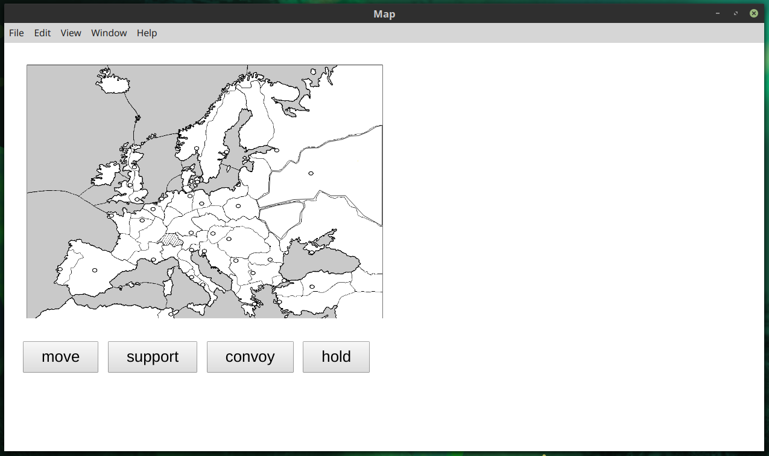

|  |  |  |  |  |
| --- | --- | --- | --- | --- |
| **COUNTRY** | **UNIT COLOR** | **UNIT CITY** | **UNIT CITY** | **UNIT CITY** |
| **Austria** | Red | A Vienna | A Budapest | F Trieste |
| **England** | Dark blue | F London | F Edinburgh | A Liverpool |
| **France** | Light blue | A Paris | A Marseilles | F Brest |
| **Germany** | Black | A Berlin | A Munich | F Kiel |
| **Italy** | Green | A Rome | A Venice | F Naples |
| **Russia** | White | A Moscow  F St. Petersburg (SC.) | F Sevastopol | A Warsaw |
| **Turkey** | Yellow | F Ankara | A Constantinople | A Smyrna |

Note: An “A” indicates an Army, and an “F” indicates a Fleet.

## 3.2 INTERACTING WITH TROOPS

By clicking a unit, you select that troop for an action. You can a then click a button to and then a province to issue that command. When you are done issuing all commands click the end turn button to submit them.

## 3.3 CHAT ROOM

Click on the chat room to start or join the online discussion. Players may send public messages that all players and spectators can view or send private messages that only the sender and recipient can view.

# 4. THE BASIC GAME RULES

## 4.1 OVERVIEW

The Diplomacy Game is played by seven players which represent the seven “Great Powers of Europe” in the years prior to World War I. Each of Great Power is subdivided into provinces. There are three types of provinces: inland, water, and coastal. Only Armies can move on inland provinces and only Fleets are allowed to move on water provinces.

There are a total of 34 inland and coastal provinces on the game board and they are designated as supply centers.

## 4.2 HOW TO PLAY

### 4.2.1 STARTING PHASE

At the start of the game, each Great Power controls three supply centers, except for Russia, which controls four supply centers. The 12 remaining supply centers aren’t occupied at the start of the game.

### 4.2.2 ORDER PHASE

The game depends on 3 major seasons: Spring, Fall, and Winter. Users can make moves during Spring and Fall. During Winter, users who have occupied new land can add new troops, others are forced to wait until Winter is over until they can make their move again.

### 4.2.3 ORDER DATES

The game begins in the year 1901 and each year consists of 3 seasons. Each of these seasons represents a specific set of conditions that the player is given.

### 4.2.4 ORDER FORMAT

When an invalid order is given the unit will act as if a hold command has been executed. The order format will then be prompted to the user given in the form of the game notation.

### 4.2.5 TYPES OF ORDERS

Types of orders are briefly detailed in the following subsections. To see a more comprehensive guide, see the Game rules from the main menu.

### 4.2.6 HOLD

Players can order a unit to stay in place by choosing to hold. Not giving a unit an order automatically gives it a hold order.

### 4.2.7 MOVE

Units can be ordered to move to neighboring areas based on their unit type. Army units can move onto any coastal province as well as land provinces. Fleet units can move onto coastal or oceanic provinces. A unit ordered to make an illegal movement will instead hold, but the game will not warn the user about the invalid move. It will only display that it was invalid after the end turn button.

When a unit is ordered to move onto an already-occupied province, it is considered an attack. Each unit has a default attack power of one which can be increased with support orders. When a unit has attack power greater than the unit being attacked, the attacked unit must retreat or disband, and the attacker seizes the province. If their powers are equal, both hold. A nation cannot dislodge its own units.

Any location on the board that isn’t named can’t be occupied. Switzerland cannot be occupied or entered. England is the only island that can be occupied.

### 4.2.8 SUPPORT

To mount a successful attack, a unit must be supported by another unit to increase its power. This is don through the support button. Any unit can support another unit regardless of unit type or nationality. Support cannot be refused even if given by another player. For example, a unit with a support can hold in place against an attacker with a support, but an attacker with two supports will dislodge the defender (strength of 3 defeats strength of 2).

To provide support, the supporting unit must have been able to move to the province being supported. During the case of a successful attack, the attacker moves into the attacked location while the supporting unit remains in place. This remains true during a failed attack, with both units remaining in place.

Support can be cut. This occurs when the unit doing the supporting is attacked by a foreign unit of any power. This results in the supported unit losing the gained strength which may cause an attack or hold by it to fail. However, support is not cut if the attack comes from the province the support is being provided to. A unit giving support may be dislodged like any other unit if attacked by a unit of higher power. Additionally, support can be cut by a unit that has been dislodged as long as the one dislodging is not from the province of the support.

### 4.2.9 CONVOY

A fleet in an ocean location can convoy army units across the water, from one coast to another. This is done by ordering the army unit to move to a coast across the ocean, then ordering the fleet to convoy them to it. The fleet must be in the water province being crossed and can only convoy one army per turn. Support cannot be convoyed. An army can be convoyed across multiple water provinces if there is a fleet in each adjacent one.

Like support, a convoy can be cut. This happens if and only if at least one fleet involved in the order is dislodged. If the fleet is attacked but not dislodged, the convoy continues as normal. If disrupted, the convoy fails, and the army unit stays in its original location.

### 4.2.10 RETREAT AND DISBAND UNITS

When a unit is attacked by a foreign unit of higher power, it must retreat to an adjacent unoccupied province. This occurs after the players have submitted orders but before the next turn begins. The next turn begins only after the dislodged unit is moved to another location. If there are unoccupied provinces for the unit to retreat to, the unit is disbanded. It is permanently destroyed.

# 5. FAQ

## 5.1 How many player(s) are needed?

The game is played by 7 players. The game can’t be started if there are less than 7 players.

## 5.2 What is the object of the game?

As soon as 1 Great Power controls 18 supply centers, it’s considered to have gained control of Europe. The player representing that Great Power is the winner. However, players can end the game by agreement before a winner is determined. In this case, all players who still have pieces on the game board share equally in a draw.

## 5.3 What are the playable countries?

One of 7 “Great Powers of Europe” in the years prior to World War I. These include England, Germany, Russia, Turkey, Italy, France, and Austria-Hungary (referred to as Austria).

## 5.4 What are the units and how do I move?

Units are supply centers designated for each player (countries) at the beginning of the game. Three supply centers are given for each country, except Russia, which is designated with 4 supply centers. To move the unit, the player clicks on adjacent provinces and make the “move” order. If the order is successful, “A Paris-Burgundy” which represent an order to move from Paris to Burgundy will be displayed on the player’s unit list.

## 5.5 How do I get more troops?

During winter, players may create new units on their starting supply centers if certain conditions are met. The player must own more supply centers than units, and the number of units they create cannot bring the total amount greater than the number of centers. A starting supply center must also be unoccupied to build a unit on it. Army units may be created at any supply center, and fleet units at any coastal supply center.

## 5.6 What are the gameplay phases?

There are three phases: Spring, Fall, and Winter phases. The game starts in Spring 1901.

## 5.7 How do I attack?

Moving and attacking are very similar actions. To attack, a unit only needs to be ordered into an already-occupied province. If the movement type is legal, the strengths of the attacker and attacked province are compared. If the attacker has greater strength, they advance to the province and force the loser to retreat or disband; otherwise, both hold. The strength is increased through use of the support command. A country cannot dislodge one of its own units.

## 5.8 What are the order types?

## There are four types of orders: hold, move, support and convoy. Only Fleets can be ordered to convoy. See [section 4.2](https://docs.google.com/document/d/1HwiTP675YQQ7-yIj33kuFh4UgjDEC-WeXYCuPUBu3IA/edit#heading=h.mveezanmf3f7) for more information.

## 5.9 How do I win the game?

## When one country occupies eighteen or more of supply centers, it is the winner of the game. However, players can end the game by an agreement they have before the winner is determined.

## Revision History

|  |  |  |
| --- | --- | --- |
| Date | Version | Description |
| 2/21/2019 | <1.0> | Original document |
|  |  |  |

# 